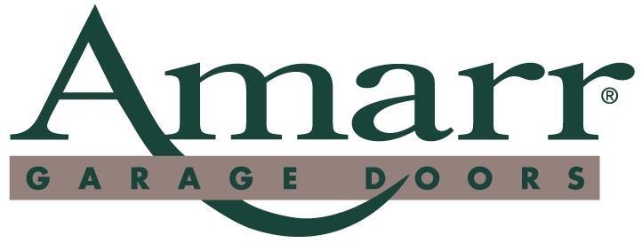

News Release

FOR IMMEDIATE RELEASE

Contact: Keith Tolbert
(336) 744-5100

Date: January 13, 2003

AMARR SIGNS LICENSING AGREEMENT WITH

BILTMORE ESTATE FOR YOUR HOME

Winston-Salem, NC – In a unique combination of form and function, Amarr Garage

Doors has entered into an agreement with Biltmore Estate For Your Home to create six

distinctive carriage house garage doors to be sold to the consumer.

The new carriage house doors will incorporate the look and feel of Biltmore Estate in

Asheville, NC. All the designs were inspired by actual carriage house and entryway

doors, as well as other architectural elements on the 8,000-acre estate in the Blue Ridge

Mountains.

“We are extremely excited about this opportunity to work with Biltmore Estate, one

of the most recognizable names in the country,” said Amarr CEO Richard Brenner. “The

beauty of the Estate has inspired many artists and craftsmen for more than a century, and

we feel privileged to follow in their footsteps.”

The doors will be built with Western Red Cedar as the base, with a Western Red Cedar

overlay. Western Red Cedar is utilized because of its stability and resistance to cracking,

165 Carriage Court, Winston-Salem, NC 27105. 336-744-5100 FAX 336-767-3805

Biltmore Estate Page 2

warping, and twisting. The base will then be screwed to a 2” commercial steel frame to

add extra durability and superior quality.

“Biltmore Estate For Your Home garage doors will not only look beautiful and be

distinctive, but will provide years of worry-free operation,” Brenner added. “Building

quality garage doors we know will last has always been the highest priority at Amarr.”

Amarr is no stranger to the carriage house garage door market. Amarr became the first

garage door company to have a branded carriage house door with the introduction of the

Bob TimberlakeTM Collection of Carriage House Doors in 2000. We added our own line

of carriage house doors called the Amarr “By Design” Custom Carriage House Doors in

2002.

“It is exciting for Biltmore Estate to have forged this partnership with Amarr because

it represents the beginning of our brands extension into an array of products for today’s

homebuilder and remodeler,” said Tim Rosebrock, Director Business Development,

Biltmore Estate Brands Group. “As a natural follow up to the launch of Biltmore Estate

Homes with Southern Living, these and future products will allow builders and

consumers to use and enjoy beautiful, well designed products in their homes with the

confidence they are getting the craftsmanship synonymous with Biltmore Estate.”

George Washington Vanderbilt completed Biltmore Estate in 1895. The 250-room

French Renaissance chateau – Biltmore House – remains much as it was when the

Vanderbilts occupied it over 100 years ago, showcasing George Vanderbilt’s collection

of furnishings, art and antiques. Biltmore Estate for Your Home draws inspiration from

the entertaining and hospitality extended to the Vanderbilt’s guests at the turn of the

165 Carriage Court, Winston-Salem, NC 27105. 336-744-5100 FAX 336-767-3805

Biltmore Estate Page 3

century. This branded program includes representations in the categories of home

furnishings, home and garden decorative accessories, permanent botanicals, home textiles

and home design.

Amarr was established in 1951 by Abe, Morris, and Herb Brenner in Winston-Salem,

NC. Quality products and loyal customers has allowed Amarr to expand steadily during

the past 50 years, making it one of the top five garage door manufacturers in the country.

Amarr manufactures a complete line of sectional overhead garage doors for both the

residential and commercial market in its Lawrence, Kansas manufacturing facility. Its

doors are sold worldwide by independent dealers and distributors who receive service

from Amarr’s 58 company-owned distribution centers located throughout the United

States, Mexico, and Canada.

###

165 Carriage Court, Winston-Salem, NC 27105. 336-744-5100 FAX 336-767-3805

