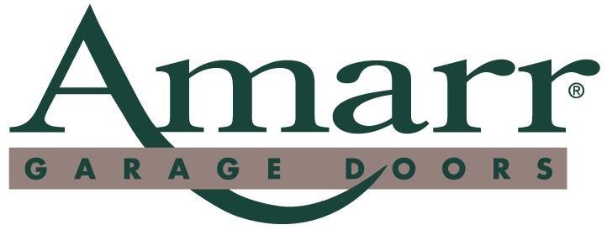

News Release

For Immediate Release

Contact: Travis Blair
(336) 744-5100
Date: June 27, 2003

Sears Named New VP, O’Dell Receives Promotion

Winston Salem, NC ⎯ Amarr is pleased to announce that Richard Sears has joined Amarr as Vice President of Development, a newly created position in the company. He will continue to work on special strategies and projects that he has been assisting with as a consultant during the past few months. In his new position, Sears has supervisory roles for the Credit Department and Treasury Department.

“I am excited to be a part of Amarr Garage Doors,” said Sears. “It is an honor to take on a brand new position in the company. One thing that is great about Amarr is the fact that everyone works as a team. Together, I believe we can continue to take this company forward and make Amarr number one.”

As a graduate of Catawba College, Sears began his career in public accounting. He has held positions as Chief Financial Officer and Treasurer of several publicly held companies. He has also owned his own business in recent years. Sears is married and has two children.

In a related move, Larry O’ Dell has been promoted from Controller to Vice President and Controller. Larry, a Wake Forest University graduate, has been with Amarr since August of 1999 spending his time equally between manufacturing in Lawrence, KS and the corporate office in North Carolina.

“I am very thankful for the opportunities Richard (Brenner, CEO) and Jeff (Mick, President) have given me to help make Amarr a great company,” O’ Dell said. “I have a wonderful group of hardworking individuals in general accounting, inventory, and product structure, both at Manufacturing and at Corporate, that have allowed me to be a successful leader of this corporation.”

Founded in 1951, Amarr Garage Doors manufactures residential and commercial garage doors and accessories. Amarr’s 58 Door Centers also distribute LiftMaster electric door operators. For more information on Amarr and its products, please call 1.800.503.DOOR or visit our web site at www.amarr.com.

# # #

165 Carriage Court, Winston-Salem, NC 27105. 336-744-5100 FAX 336-767-3805

